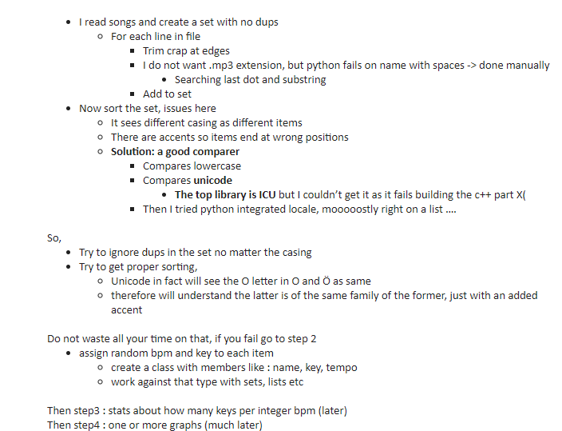

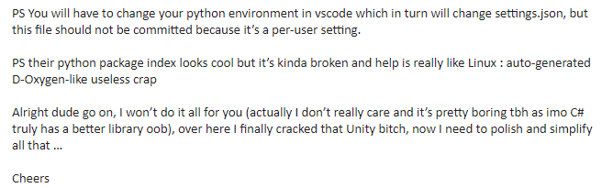

|  |
| --- |
| + |
| +songs = set() |
| + |
| +with open("songs.txt", encoding='utf-8') as file: |
| + for line in file: |
| + # remove crap |
| + clean = line.strip(' ') |
| + clean = clean.strip('\r') |
| + clean = clean.strip('\n') |
| + clean = clean.strip('\"') |
| + |
| + # get filename only |
| + last_dot = clean.rfind('.') |
| + length = last_dot if last_dot >= 0 else len(clean) |
| + name = clean[:length] |
| + |
| + # store |
| + songs.add(name) |
| + |
| +sorted_set = sorted(songs, key=str.lower) |
| + |
| +# this is an attempt to use python local sort but only works on lists, |
| +# it fetches system local but does US not know about accents ... left as reference |
| +# import locale |
| +# locale.setlocale(locale.LC_ALL, "") |
| +# songs.sort(cmp=locale.strxfrm) |
| + |
| +# the top notch alternative is PyICU but couldn't get it up |
| + |
| +# just a placeholder breakpoint so the program doesn't stop abruptly |
| +total_songs = len(songs) |